**CRIMINAL IDENTIFICATION IN COLOR SKIN IMAGES USING SKIN MARKS AND FUSION WITH INFERRED VEIN PATTERNS**

**ABSTRACT**

Skin texture without obvious features is different from other hard biometrics on the skin, such as fingerprints and palmprints. Relatively Permanent Pigmented or Vascular Skin Marks (RPPVSM) were recently introduced as a biometric trait for identification in cases where the evidence images show only the non-facial body parts of the criminals or victims, such as in child sexual abuse and riots. As manual RPPVSM identification is tiring and time consuming, an automated criminal identification system is proposed in this paper. The system is comprised of skin image enhancement, skin segmentation, vein pattern extraction and matching algorithms. Various numbers of algorithms are used in different stages of our proposed work. The system was evaluated on back images collected from different subjects in varying pose and viewpoint conditions. The proposed algorithm is computationally efficient and consistent in skin segmentation. To the best of our knowledge, this is the first work on automated identification in color skin images based on non-facial skin marks and fusion with inferred vein patterns in forensic settings.

**CHAPTER I**

**INTRODUCTION-IMAGE PROCESSING**

* 1. **GENERAL**

The term digital image refers to processing of a two dimensional picture by a digital computer. In a broader context, it implies digital processing of any two dimensional data. A digital image is an array of real or complex numbers represented by a finite number of bits. An image given in the form of a transparency, slide, photograph or an X-ray is first digitized and stored as a matrix of binary digits in computer memory. This digitized image can then be processed and/or displayed on a high-resolution television monitor. For display, the image is stored in a rapid-access buffer memory, which refreshes the monitor at a rate of 25 frames per second to produce a visually continuous display.

**1.1.1THE IMAGE PROCESSING SYSTEM**

**DIGITIZER**

**MASS STORAGE**

**HARD COPY DEVICE**

**DISPLAY**

**IMAGE PROCESSOR**

**DIGITAL COMPUTER**

**OPERATOR CONSOLE**

**FIG 1.1 BLOCK DIAGRAM FOR IMAGE PROCESSING SYSTEM**

* **DIGITIZER**

A digitizer converts an image into a numerical representation suitable for input into a digital computer. Some common digitizers are

* Microdensitometer
* Flying spot scanner
* Image dissector
* Videocon camera
* Photosensitive solid- state arrays.
* **IMAGE PROCESSOR**

An image processor does the functions of image acquisition, storage, preprocessing, segmentation, representation, recognition and interpretation and finally displays or records the resulting image. The following block diagram gives the fundamental sequence involved in an image processing system.

**PROBLEM DOMAIN**

**KNOWLEDGE**

**BASE**

**SEGMENTATION**

**PREPROCESSING**

**IMAGE ACQUISITION**

**RECOGNITION & INTERPRETATION**

**REPRESENTATION & DESCRIPTION**

**RESULT**

**FIG 1.2 BLOCK DIAGRAM OF FUNDAMENTAL SEQUENCE INVOLVED IN AN IMAGE PROCESSING SYSTEM**

As detailed in the diagram, the first step in the process is image acquisition by an imaging sensor in conjunction with a digitizer to digitize the image. The next step is the preprocessing step where the image is improved being fed as an input to the other processes. Preprocessing typically deals with enhancing, removing noise, isolating regions, etc. Segmentation partitions an image into its constituent parts or objects. The output of segmentation is usually raw pixel data, which consists of either the boundary of the region or the pixels in the region themselves. Representation is the process of transforming the raw pixel data into a form useful for subsequent processing by the computer. Description deals with extracting features that are basic in differentiating one class of objects from another. Recognition assigns a label to an object based on the information provided by its descriptors. Interpretation involves assigning meaning to an ensemble of recognized objects. The knowledge about a problem domain is incorporated into the knowledge base. The knowledge base guides the operation of each processing module and also controls the interaction between the modules. Not all modules need be necessarily present for a specific function. The composition of the image processing system depends on its application. The frame rate of the image processor is normally around 25 frames per second.

* **DIGITAL COMPUTER**

Mathematical processing of the digitized image such as convolution, averaging, addition, subtraction, etc. are done by the computer.

* **MASS STORAGE**

The secondary storage devices normally used are floppy disks, CD ROMs etc.

* **HARD COPY DEVICE**

The hard copy device is used to produce a permanent copy of the image and for the storage of the software involved.

* **OPERATOR CONSOLE**

The operator console consists of equipment and arrangements for verification of intermediate results and for alterations in the software as and when require. The operator is also capable of checking for any resulting errors and for the entry of requisite data.

* + 1. **IMAGE PROCESSING FUNDAMENTAL**

Digital image processing refers processing of the image in digital form. Modern cameras may directly take the image in digital form but generally images are originated in optical form. They are captured by video cameras and digitalized. The digitalization process includes sampling, quantization. Then these images are processed by the five fundamental processes, at least any one of them, not necessarily all of them.

**IMAGE PROCESSING TECHNIQUES**

This section gives various image processing techniques.

Image Enhancement

Image Restoration

Image Analysis

Image Compression

Image Synthesis

**FIG 1.3: IMAGE PROCESSING TECHNIQUES**

* **IMAGE ENHANCEMENT**

Image enhancement operations improve the qualities of an image like improving the image’s contrast and brightness characteristics, reducing its noise content, or sharpen the details. This just enhances the image and reveals the same information in more understandable image. It does not add any information to it.

* **IMAGE RESTORATION**

Image restoration like enhancement improves the qualities of image but all the operations are mainly based on known, measured, or degradations of the original image. Image restorations are used to restore images with problems such as geometric distortion, improper focus, repetitive noise, and camera motion. It is used to correct images for known degradations.

* **IMAGE ANALYSIS**

Image analysis operations produce numerical or graphical information based on characteristics of the original image. They break into objects and then classify them. They depend on the image statistics. Common operations are extraction and description of scene and image features, automated measurements, and object classification. Image analyze are mainly used in machine vision applications.

* **IMAGE COMPRESSION**

Image compression and decompression reduce the data content necessary to describe the image. Most of the images contain lot of redundant information, compression removes all the redundancies. Because of the compression the size is reduced, so efficiently stored or transported. The compressed image is decompressed when displayed. Lossless compression preserves the exact data in the original image, but Lossy compression does not represent the original image but provide excellent compression.

* **IMAGE SYNTHESIS**

Image synthesis operations create images from other images or non-image data. Image synthesis operations generally create images that are either physically impossible or impractical to acquire.

**1.1.3 Image types**

There are several ways of encoding the information in an image.

1. Binary image
2. Grayscale image
3. Indexed image
4. True color or RGB image

* **Binary image**

Each pixel is just blackor white. Since there are only two possible values for each pixel (0, 1), we only need one bitper pixel.

* **Grayscale image**

Each pixel is a shade of gray, normally from 0 (black) to 255(white). This range means that each pixel can be represented by eight bits, or exactly one byte. Other grayscale ranges are used, but generally they are a power of 2.

* **Indexed image**

An indexed image consists of an array and a color map matrix. The pixel values in the array are direct indices into a color map. By convention, this documentation uses the variable name X to refer to the array and map to refer to the color map.

* **True Color or RGB image**

Each pixel has a particular color; that color is described by the amount of red, greenand bluein it. If each of these components has a range 0–255, this gives a total of 2563different possible colors. Such an image is a “stack” of three matrices; representing the red, greenand bluevalues for each pixel. This means that for every pixel there correspond 3 values.

**1.1.4 APPLICATIONS of image processing**

Image processing has an enormous range of applications; almost every area of science and technology can make use of image processing methods. Here is a short list just to give some indication of the range of image processing applications.

* **DOCUMENT PROCESSING**

It is used in scanning, and transmission for converting paper documents to a digital image form, compressing the image, and storing it on magnetic tape. It is also used in document reading for automatically detecting and recognizing printed characteristics.

* **Medicine**

Inspection and interpretation of images obtained from X-rays, MRI or CAT scans, analysis of cell images, of chromosome karyotypes. In medical applications, one is concerned with processing of chest X-rays, cineangiograms, projection images of transaxial tomography and other medical images that occur in radiology, nuclear magnetic resonance (NMR) and ultrasonic scanning. These images may be used for patient screening and monitoring or for detection of tumors’ or other disease in patients.

* **Industry**

Automatic inspection of items on a production line, inspection of paper samples.

* **DEFENSE/INTELLIGENCE**

It is used in reconnaissance photo-interpretation for automatic interpretation of earth satellite imagery to look for sensitive targets or military threats and target acquisition and guidance for recognizing and tracking targets in real-time smart-bomb and missile-guidance systems.

* **RADAR IMAGING SYSTEM**

Radar and sonar images are used for detection and recognition of various types of targets or in guidance and maneuvering of aircraft or missile systems.

* **Agriculture**

Satellite/aerial views of land, for example to determine how much land is being used for different purposes, or to investigate the suitability of different regions for different crops, inspection of fruit and vegetables distinguishing good and fresh produce from old.

**CHAPTER 2**

**INTRODUCTION-CRIMINAL IDENTIFICATION**

A skin recognition system is a computer application capable of identifying or verifying a person from a digital image or a video frame from a video source. One of the ways to do this is by comparing selected skin features from the image and facial database. It is typically used in security systems and can be compared to other biometric such as fingerprint or eye iris recognition systems. Recently, it has also become popular as commercial identification and marketing tool.

**TECHNOLOGIES**

**TRADITIONAL**

Some facial recognition algorithm identifies facial features by extracting landmarks, or features from an image of the subjects face. For example, an algorithm may analyze the relative portion, size, and /or shape of the eyes, nose, cheekbones, and jaw. These features are then used to search for other images with matching features. Other algorithms normalize a gallery of face images and then compress the face data, only saving the data in the image that is useful for face recognition. A probe image is then compared with the face data. One of the earliest successful systems is based on template matching technique applied to a set of salient facial features, providing a sort of compressed face representation.

Recognition algorithm can be divided into two main approaches, geometry, which looks at distinguishing features, or photometric which is statistical approach that distills an image into values and compares the values with templates to eliminate the variances.

**3-DIMENSIONAL RECOGNITION**

A newly emerging trend, claimed to achieve improved accuracies, is three-dimensional skin recognition. This technique used 3D sensors to capture information about the shape of a face. This information is then used to identify distinctive features on the surface of skin. One advantage of 3D skin recognition is that it is not affected by changes in lightning like other techniques. It can also identify a skin from a range of viewing angels, including profile view. Three-dimension data points from s skin vastly improve the precision of skin recognition 2D research is enhanced by the development of sophisticated sensors that do a better job of capturing 3D skin imagery. The sensor works by projecting structured light on the face. Up to a dozen or more these image sensors can be placed on the CMOS chip- each sensor captures a different part of the spectrum.

**SKIN TEXTURE ANALYSIS**

Another emerging trend uses the visual details of the skin, as captured in standard digital or scanned images. This technique, called skin texture analysis, turns the unique lines, patterns, and spots apparently in a person’s skin into mathematical space. Test have shown that with addition of skin texture analysis, performance in recognition faces can increase 20 to 25 percent.

**THERMAL CAMERAS**

A different form of taking input data for face recognition is by using thermal cameras, by this procedure the cameras will only detect the shape of the head and it will ignore the subject accessories such as glasses, hats, or make up. A problem with using thermal pictures for face recognition is that the databases for face recognition are limited. The research uses low sensitive, low-resolution ferro-electric electrics sensors that are capable of acquiring long wave thermal infrared.

**ADVANTAGES AND DISADVANTAGES**

**COMPARED TO OTHER TECHNOLOGIES**

Among the different biometric techniques, facial recognition may not be most reliable and efficient. However, one key advantage is that it does not require corporate of the test subject to work. Properly designed systems installed in airports. Multiplexes, and other public places can identify individual among the crowd, without passers-by even being aware of the system. Other biometrics like fingerprint, iris scans, and speech recognition cannot performs this kind of mass identification.

**WEAKNESS**

Face recognition is not perfect and struggles to perform under certain condition. Other conditions where face recognition does not work well include poor lighting, sunglasses, long hair or other objects partially covering the subjects face and low resolution images. There is also inconstancy in the datasets used by researchers. Researchers may use anywhere from several subjects to scores of subjects, and few hundred images to thousand of images. It is important for researchers to make availability of datasets they used to each other, or have at least a standard dataset.

**PRIVACY ISSUES**

Civil rights right organization and privacy campaigners such as EFF and the ACLU express concern privacy is being compromised by the use of surveillance technologies. Some fear that it could lead to a “total surveillance society” with the government and other authorities having ability to know the where about and activities of all citizens around the clock. Skin recognition can be used not just to identify individual such as other photos featuring the individual. This fundamental changes the dynamic of day-to-day privacy by enabling any marketer, government agency, or random stranger to secretly collect the identifies and associated personal information of any individual captured by the skin recognition system.

**CHAPTER 3**

**PROJECT METHODOLOGIES**

**3.1 OBJECTIVE**

* To propose an automated people identification system based on back skin images as a biometric trait for identification of the criminals and victims.
* To enhance and segment the skin region.
* To extract the blood vessels and vein patterns of the skin images.

**3.2 EXISTING SYSTEM**

* Several skin mark detection and matching methods have been proposed in literature for face recognition systems, where skin marks are used as additional discriminative features (e.g., to discriminate monozygotic twins) or alternative identification features when face recognition fails.
* Zhang et al. detected facial marks in a semi-automated fashion by manually labeling seed pixels of facial marks and using region growing operations to grow the seeds of the selected facial marks from one pixel into a group of pixels with similar intensity.
* Park and Jain introduced facial marks together with gender and ethnicity as soft biometric traits to improve the performance of face matching and retrieval.
* Srinivas et al. used facial marks as a standalone biometric for identifying monozygotic twins.

**3.3.1 EXISTING SYSTEM DISADVANTAGES**

* Gunmen, terrorists, and rioters often cover their faces with masks or clothing, making face recognition impossible.
* The same challenges are encountered in the cases of child sexual abuse (e.g., child pornography), where pedophiles’ faces and tattoos are rarely visible in the evidence images or purposely blurred to avoid recognition
* Skin portions are not segmented properly
* Image quality is Poor.
* Computational Complexity is high.
  1. **PROPOSED SYSTEM**

While it is rare to observe the criminals’ faces in the evidence images of child sexual abuse, masked gunmen, and riots, their non-facial body parts are often visible. To identify the criminals in these skin images, in this paper we propose an automated criminal identification system, which is comprised of skin image enhancement, skin segmentation, RPPVSM detection, and vein pattern matching algorithms. The RGB image can be converted into Red channel, Green channel and Blue channel and YCbCr color space model. Luminance (Y) channel, Chrominance (Cb) channel and Chrominance (Cr) channel. We Apply Gray world algorithm to the YCbCr output image in order to enhance the image. Mean/Average Filter is applied to all the three channels in the YCbCr image and Mean filtered normalized RGB image is obtained. Fuzzy C-Means (FCM) Segmentation algorithm is used to segment the backskin images from the background. Masking is applied and the color skin segmentation is done. Further to enhance the image, Contrast Limited Adaptive Histogram Equalization (CLAHE) is applied. Gabor Filter is used for extracting the vein pattern. Local Binary Patterns (LBP) is also used for extracting the texture feature extracted image. Shape Features are measured for all the registered criminals and the new testing image and it is classified using Multisvm algorithm. If it is matched, then it results as Registered Criminals. If it is not matched, it results as unregistered and new one.

**PROPOSED SYSTEM BLOCK DIAGRAM**

**VEIN MATCHING**

**VEIN PATTERN EXTRACTION**

**IMAGE ENHANCEMENT**

**CRIME SCENERGB IMAGE**

**BACKSKIN IMAGE SEGMENTATION**

**IMAGE NORMALIZATION**

**TESTING FEATURE VALUES**

**VEIN PATTERN EXTRACTION**

**IMAGE ENHANCEMENT**

**(DATA-BASE)**

**RGB IMAGE**

**BACKSKIN IMAGE SEGMENTATION**

**IMAGE NORMALIZATION**

**CLASSIFICATION/ MATCHING**

**TRAINED FEATURE VALUES**

**RECOGNIZED**

**NOT RECOGNIZED**

**UNREGISTERED CRIMINAL**

**REGISTERED CRIMINAL**

**3.4.1 PROPOSED ADVANTAGES**

* This is the Novel approach and the first systematic study on non-facial skin marks
* This work is the first systematic study on non-facial skin marks and their fusion with vein patterns for automated criminal identification in color skin images in forensic settings..
* High accuracy in vein identification
* Segmentation Accuracy is high.
* The proposed system is robust and very effective.

**3.4.2 PROPOSED TECHNIQUES**

* Channel conversion RGB,YcbCr
* Image Normalization
* Histogram Analysis
* Fuzzy C-Means (FCM) Segmentation algorithm
* Homomorphic filtering (Preprocessing)
* Multiscale filtering and Thresholding (Candidate Extraction)
* Contrast Limited Adaptive Histogram Equalization (CLAHE) (Image Enhancement)
* Local Binary Pattern (LBP) (Feature Extraction)
* Gabor Filter (Vein Pattern Extraction)
* Shape feature extraction
* MultiSVM (Classification)

**CHAPTER 4**

**LITERATURE SURVEY**

In the 2017 paper, “A Finger Vein Image-Based Personal Identification System With Self-Adaptive Illuminance Control” Liukui Chen, Jing Wang, Shiyu Yang, and Haibo Heproposed a system in which the human recognition and identification can be done based on the extracted features from the finger vein images. The design of a personal identification system based on near infrared (NIR) finger vein image. They enhance the low resolution images by combining the enhancement technique such as Contrast Limited Adaptive Histogram Equalization (CLAHE) and median filter. The segmentation of Region of Interest (ROI) at different resolution levels and the orientation and rotation translations (invariant to rotations) makes the system highly efficient. They propose a familiar technique Gabor Filter for feature extraction process which improves the overall accuracy of the system.

In the paper, “Finger Vein Recognition Using Integrated Responses of Texture Features,” H. A. Quigley and A. T. Broman proposed a unique technique to find the local and the global features using Integrated Responses of Texture (IRT) features from finger veins which improves the accuracy of the system and is invariant to rotations. Thus, an effective feature extraction technique termed as Integrated Responses of Texture using Local Binary Pattern is proposed in which different resolution levels of Texture using LBP is concatenated to form a complete set of features which describes the local and the global features more prominently.

During 1964 and 1965, Bledsoe, along with Helen Chan and Charles Bison, worked on using the computer to recognize human faces (Bledsoe 1966a, 1966b; Bledsoe and Chan 1965). He was proud of this work, but because the funding was provided by an unnamed intelligence agency that did not allow much publicity, little of the work was published. Given a large database of images (in effect, a book of mug shots) and a photograph, the problem was to select from the database a small set of records such that one of the image records matched the photograph. The success of the method could be measured in terms of the ratio of the answer list to the number of records in the database. Bledsoe (1966a) described the following difficulties:

|  |  |  |
| --- | --- | --- |
|  |  |  |
|  | | |

This project was labeled man-machine because the human extracted the coordinates of a set of features from the photographs, which were then used by the computer for recognition. Using a [graphics tablet](https://en.wikipedia.org/wiki/Graphics_tablet) (GRAFACON or [RAND TABLET](https://en.wikipedia.org/wiki/RAND_Tablet)), the operator would extract the coordinates of features such as the center of pupils, the inside corner of eyes, the outside corner of eyes, point of [widows peak](https://en.wikipedia.org/wiki/Widows_peak), and so on. From these coordinates, a list of 20 distances, such as width of mouth and width of eyes, pupil to pupil, were computed. These operators could process about 40 pictures an hour. When building the database, the name of the person in the photograph was associated with the list of computed distances and stored in the computer. In the recognition phase, the set of distances was compared with the corresponding distance for each photograph, yielding a distance between the photograph and the database record. The closest records are returned.

Because it is unlikely that any two pictures would match in head rotation, lean, tilt, and scale (distance from the camera), each set of distances is normalized to represent the face in a frontal orientation. To accomplish this normalization, the program first tries to determine the tilt, the lean, and the rotation. Then, using these angles, the computer undoes the effect of these transformations on the computed distances. To compute these angles, the computer must know the three-dimensional geometry of the head. Because the actual heads were unavailable, Bledsoe (1964) used a standard head derived from measurements on seven heads.

After Bledsoe left PRI in 1966, this work was continued at the [Stanford Research Institute](https://en.wikipedia.org/wiki/Stanford_Research_Institute), primarily by [Peter Hart](https://en.wikipedia.org/wiki/Peter_E._Hart). In experiments performed on a database of over 2000 photographs, the computer consistently outperformed humans when presented with the same recognition tasks (Bledsoe 1968). Peter Hart (1996) enthusiastically recalled the project with the exclamation, "It really worked!"

By about 1997, the system developed by Christoph von der Malsburg and [graduate students](https://en.wikipedia.org/wiki/Graduate_student) of the [University of Bochum](https://en.wikipedia.org/wiki/University_of_Bochum) in Germany and the [University of Southern California](https://en.wikipedia.org/wiki/University_of_Southern_California) in the United States outperformed most systems with those of [Massachusetts Institute of Technology](https://en.wikipedia.org/wiki/Massachusetts_Institute_of_Technology) and the [University of Maryland](https://en.wikipedia.org/wiki/University_of_Maryland,_College_Park) rated next. The Bochum system was developed through funding by the [United States Army Research Laboratory](https://en.wikipedia.org/wiki/United_States_Army_Research_Laboratory). The [software](https://en.wikipedia.org/wiki/Software) was sold as [ZN-Face](https://en.wikipedia.org/w/index.php?title=ZN-Face&action=edit&redlink=1) and used by customers such as [Deutsche Bank](https://en.wikipedia.org/wiki/Deutsche_Bank)and operators of [airports](https://en.wikipedia.org/wiki/Airport) and other busy locations. The software was "robust enough to make identifications from less-than-perfect face views. It can also often see through such impediments to identification as mustaches, beards, changed hair styles and glasses—even sunglasses".

In about January 2007, image searches were "based on the text surrounding a photo," for example, if text nearby mentions the image content. Polar Rose technology can guess from a photograph, in about 1.5 seconds, what any individual may look like in three dimensions, and claimed they "will ask users to input the names of people they recognize in photos online" to help build a database[*.* In 2006, the performance of the latest face recognition algorithms were evaluated in the Identix, a company out of Minnesota, has developed the software, FaceIt. FaceIt can pick out someone’s face in a crowd and compare it to databases worldwide to recognize and put a name to a face. The software is written to detect multiple features on the human face. It can detect the distance between the eyes, width of the nose, shape of cheekbones, length of jaw lines and many more skin features. The software does this by putting the image of the face on a face print, a numerical code that represents the human face. Skin recognition software used to have to rely on a 2D image with the person almost directly facing the camera. Now, with FaceIt, a 3D image can be compared to a 2D image by choosing 3 specific points off of the 3D image and converting it into a 2D image using a special algorithm that can be scanned through almost all databases.  [Face Recognition Grand Challenge (FRGC)](https://en.wikipedia.org/wiki/Face_Recognition_Grand_Challenge_(FRGC)). High-resolution face images, 3-D face scans, and iris images were used in the tests. The results indicated that the new algorithms are 10 times more accurate than the face recognition algorithms of 2002 and 100 times more accurate than those of 1995. Some of the algorithms were able to outperform human participants in recognizing faces and could uniquely identify identical twins.

U.S. Government-sponsored evaluations and challenge problems have helped spur over two orders-of-magnitude in face-recognition system performance. Since 1993, the error rate of automatic face-recognition systems has decreased by a factor of 272. The reduction applies to systems that match people with face images captured in studio or mug shot environments. In [Moore's law](https://en.wikipedia.org/wiki/Moore%27s_law) terms, the error rate decreased by one-half every two years.

Low-resolution images of faces can be enhanced using [face hallucination](https://en.wikipedia.org/wiki/Face_hallucination). Further improvements in high resolution, megapixel cameras in the last few yearshave helped to resolve the issue of insufficient resolution.

Even though skin marks in evidence images can be manually by investigators or expert witnesses, it is nearly impossible to process criminal databases manually due to their large size and complexity.

**CHAPTER 5**

**MODULE DESCRIPTION**

**5.1 MODULE NAMES**

* RGB To Channel Conversion
* Image Preprocessing (Enhancement)
* Segmentation
* Feature Extraction
* Classification

**5.2 MODULE DESCRIPTIONS**

**MODULE 1**

**RGB TO CHANNEL CONVERSION**

* The input is the criminal image in color from. Since it is RGB image it has three channels, The output is the red green and blue channel image

**MODULE 2**

**IMAGE PREPROCESSING**

It describes the individual functionalities performed during preprocessing phase.

* The RGB image can be converted into Red channel, Green channel and Blue channel
* The RGB image is converted into YCbCr color space model.
* The YCbCr image can be converted into Luminance (Y) channel, Chrominance (Cb) channel and Chrominance (Cr) channel
* Apply Gray world algorithm to the YCbCr output image in order to enhance the image.
* Mean/Average Filter is applied to all the three channels in the YCbCr image and Mean filtered normalized RGB image is obtained.

**MODULE – 3**

**IMAGE SEGMENTATION**

The grayscale image is converted into binary image in which the skin regions are detected in white color and the background objects become black color. We use Thresholding algorithm.

**THRESHOLDING**

Binarization is a process where each pixel in an image is converted into one bit and you assign the value as '1' or '0' depending upon the mean value of all the pixel. If greater then mean value then its '1' otherwise its '0'.

Image binarization converts an image of up to 256 gray levels to a black and white image. Frequently, binarization is used to convert the grayscale image into binary image with the aim of making the skin regions in white color and the background regions in black color. The tumor can be segmented and shown from the image.

The simplest way to use image binarization is to choose a threshold value, and classify all pixels with values above this threshold as white, and all other pixels as black. For selecting the threshold, we are using Otsu threshold algorithm.

**MORPHOLOGICAL OPERATIONS**

Morphological operations such as connected component removal are used to remove the unwanted objects and segment the skin region images only based on gray level intensity.

**MODULE – 4**

**FEATURE EXTRACTION**

**COLOR FEATURE**

The color feature is one of the most widely used visual features in image retrieval. The construction of the color histogram is a straightforward process, including scanning the image, assigning color values to the resolution of the histogram, and building the histogram using color components as indices. There exist various color model to describe color information.

A color model is specified in terms of 3-D coordinate system and a subspace within that system where each color is represented by a single point. The more commonly used color models are *RGB* (red, green, blue), *HSV* (hue, saturation, value) and YCbCr (luminance and chrominance). We extracted the mean, standard deviation values of the color channels.

**SHAPE FEATURE**

Shape is an important visual feature and it is one of the primitive features for image content description. Shape content description is difficult to define because measuring the similarity between shapes is difficult. Region-based methods use the whole area of an object for shape description. The Area, Major Axis length and Minor Axis length are the features measured for the given image.

**MODULE – 5**

**CLASSIFICATION**

**SVM CLASSIFICATION**

Finally, SVM classifier is made using the whole model of feature subset selection. The pattern classification is defined as the task to categorize any object within a given category called class. For this paper, the classification stage was made using a support vector machine (SVM).

**CHAPTER 6**

**SOFTWARE SPECIFICATION**

**6.1 GENERAL**

This paper proposes a novel nonrigid inter-subject multichannel image registration method which combines information from different modalities/channels to produce a unified joint registration. Multichannel images are created using co-registered multimodality images of the same subject to utilize information across modalities comprehensively. Contrary to the existing methods which combine the information at the image/intensity level, the proposed method uses feature-level information fusion method to spatio-adaptively combine the complementary information from different modalities that characterize different tissue types, through Gabor wavelets transformation and Independent Component Analysis (ICA), to produce a robust inter-subject registration.

**6.2 SOFTWARE REQUIREMENTS**

* MATLAB 8.3 Version R2014a

**MATLAB**

MATLAB is a high-performance language for technical computing. It integrates computation, visualization, and programming in an easy-to-use environment where problems and solutions are expressed in familiar mathematical notation.

Typical uses include:

* Math and computation
* Algorithm development
* Modeling, simulation, and prototyping
* Data analysis, exploration, and visualization
* Scientific and engineering graphics.
* Application development, including Graphical User Interface building

MATLAB is an interactive system whose basic data element is an array that does not require dimensioning. This allows you to solve many technical computing problems, especially those with matrix and vector formulations, in a fraction of the time it would take to write a program in a scalar non-interactive language such as C or FORTRAN

**6.3 INTRODUCTION**

**MATLAB** (**mat**rix **lab**oratory) is a [numerical computing](http://en.wikipedia.org/wiki/Numerical_analysis) environment and [fourth-generation programming language](http://en.wikipedia.org/wiki/Fourth-generation_programming_language). Developed by [Math Works](http://en.wikipedia.org/wiki/MathWorks), MATLAB allows [matrix](http://en.wikipedia.org/wiki/Matrix_(mathematics)) manipulations, plotting of [functions](http://en.wikipedia.org/wiki/Function_(mathematics)) and data, implementation of [algorithms](http://en.wikipedia.org/wiki/Algorithm), creation of [user interfaces](http://en.wikipedia.org/wiki/User_interface), and interfacing with programs written in other languages, including [C](http://en.wikipedia.org/wiki/C_(programming_language)), [C++](http://en.wikipedia.org/wiki/C%2B%2B), [Java](http://en.wikipedia.org/wiki/Java_(programming_language)), and [Fortran](http://en.wikipedia.org/wiki/Fortran).

Although MATLAB is intended primarily for numerical computing, an optional toolbox uses the [MuPAD](http://en.wikipedia.org/wiki/MuPAD) [symbolic engine](http://en.wikipedia.org/wiki/Computer_algebra_system), allowing access to [symbolic computing](http://en.wikipedia.org/wiki/Symbolic_computing) capabilities. An additional package, [Simulink](http://en.wikipedia.org/wiki/Simulink), adds graphical multi-domain simulation and [Model-Based Design](http://en.wikipedia.org/wiki/Model_based_design) for [dynamic](http://en.wikipedia.org/wiki/Dynamical_system) and [embedded systems](http://en.wikipedia.org/wiki/Embedded_systems).

In 2004, MATLAB had around one million users across industry and academia. MATLAB users come from various backgrounds of [engineering](http://en.wikipedia.org/wiki/Engineering), [science](http://en.wikipedia.org/wiki/Science), and [economics](http://en.wikipedia.org/wiki/Economics). MATLAB is widely used in academic and research institutions as well as industrial enterprises.

MATLAB was first adopted by researchers and practitioners in [control engineering](http://en.wikipedia.org/wiki/Control_engineering), Little's specialty, but quickly spread to many other domains. It is now also used in education, in particular the teaching of [linear algebra](http://en.wikipedia.org/wiki/Linear_algebra) and [numerical analysis](http://en.wikipedia.org/wiki/Numerical_analysis), and is popular amongst scientists involved in [image processing](http://en.wikipedia.org/wiki/Image_processing). The MATLAB application is built around the MATLAB language. The simplest way to execute MATLAB code is to type it in the Command Window, which is one of the elements of the MATLAB Desktop. When code is entered in the Command Window, MATLAB can be used as an interactive mathematical [shell](http://en.wikipedia.org/wiki/Shell_(computing)). Sequences of commands can be saved in a text file, typically using the MATLAB Editor, as a [script](http://en.wikipedia.org/wiki/Shell_script) or encapsulated into a [function](http://en.wikipedia.org/wiki/Functional_programming), extending the commands available.

MATLAB provides a number of features for documenting and sharing your work. You can integrate your MATLAB code with other languages and applications, and distribute your MATLAB algorithms and applications.

**6.4 FEATURES of matlab**

* High-level language for technical computing.
* Development environment for managing code, files, and data.
* Interactive tools for iterative exploration, design, and problem solving.
* Mathematical functions for linear algebra, statistics, Fourier analysis, filtering, optimization, and numerical integration.
* 2-D and 3-D graphics functions for visualizing data.
* Tools for building custom graphical user interfaces.
* Functions for integrating MATLAB based algorithms with external applications and languages, such as C, C++, Fortran, Java™, COM, and Microsoft Excel.

MATLAB is used in vast area, including signal and image processing, communications, control design, [test and measurement](http://www.mathworks.in/applications/t_m), financial modeling and analysis, and computational. Add-on toolboxes (collections of special-purpose MATLAB functions) extend the MATLAB environment to solve particular classes of problems in these application areas.

MATLAB can be used on personal computers and powerful server systems, including the [Cheaha](http://docs.uabgrid.uab.edu/wiki/Cheaha) compute cluster. With the addition of the Parallel Computing Toolbox, the language can be extended with parallel implementations for common computational functions, including for-loop unrolling. Additionally this toolbox supports offloading computationally intensive workloads to [Cheaha](http://docs.uabgrid.uab.edu/wiki/Cheaha) the campus compute cluster.MATLAB is one of a few languages in which each variable is a matrix (broadly construed) and "knows" how big it is. Moreover, the fundamental operators (e.g. addition, multiplication) are programmed to deal with matrices when required. And the MATLAB environment handles much of the bothersome housekeeping that makes all this possible. Since so many of the procedures required for Macro-Investment Analysis involves matrices, MATLAB proves to be an extremely efficient language for both communication and implementation.

**6.4.1 INTERFACING WITH OTHER LANGUAGES**

MATLAB can call functions and subroutines written in the [C programming language](http://en.wikipedia.org/wiki/C_(programming_language)) or [FORTRAN](http://en.wikipedia.org/wiki/Fortran). A wrapper function is created allowing MATLAB data types to be passed and returned. The dynamically loadable object files created by compiling such functions are termed "[MEX-files](http://en.wikipedia.org/wiki/MEX_file)" (for **M**ATLAB **ex**ecutable).

Libraries written in [Java](http://en.wikipedia.org/wiki/Java_(programming_language)), [ActiveX](http://en.wikipedia.org/wiki/ActiveX) or [.NET](http://en.wikipedia.org/wiki/.NET_Framework) can be directly called from MATLAB and many MATLAB libraries (for example [XML](http://en.wikipedia.org/wiki/XML) or [SQL](http://en.wikipedia.org/wiki/SQL) support) are implemented as wrappers around Java or ActiveX libraries. Calling MATLAB from Java is more complicated, but can be done with MATLAB extension, which is sold separately by Math Works, or using an undocumented mechanism called JMI (Java-to-Mat lab Interface), which should not be confused with the unrelated Java that is also called JMI.

As alternatives to the [MuPAD](http://en.wikipedia.org/wiki/MuPAD) based Symbolic Math Toolbox available from Math Works, MATLAB can be connected to [Maple](http://en.wikipedia.org/wiki/Maple_(software)) or [Mathematica](http://en.wikipedia.org/wiki/Mathematica).

Libraries also exist to import and export [MathML](http://en.wikipedia.org/wiki/MathML).

* **Development Environment**
* Startup Accelerator for faster MATLAB startup on Windows, especially on Windows XP, and for network installations.
* [Spreadsheet Import Tool](http://www.mathworks.in/videos/matlab/new-spreadsheet-import-tool-in-r2011b.html?type=shadow) that provides more options for selecting and loading mixed textual and numeric data.
* Readability and navigation improvements to warning and error messages in the MATLAB command window.
* [Automatic variable and function renaming](http://www.mathworks.in/videos/matlab/new-automatic-variable-and-function-renaming-in-r2011b.html?type=shadow) in the MATLAB Editor.
* **Developing Algorithms and Applications**

MATLAB provides a high-level language and development tools that let you quickly develop and analyze your algorithms and applications.

* **The MATLAB Language**

The MATLAB language supports the vector and matrix operations that are fundamental to engineering and scientific problems. It enables fast development and execution. With the MATLAB language, you can program and develop algorithms faster than with traditional languages because you do not need to perform low-level administrative tasks, such as declaring variables, specifying data types, and allocating memory. In many cases, MATLAB eliminates the need for ‘for’ loops. As a result, one line of MATLAB code can often replace several lines of C or C++ code.

At the same time, MATLAB provides all the features of a traditional programming language, including arithmetic operators, flow control, data structures, data types, [object-oriented programming](http://www.mathworks.in/products/matlab/object_oriented_programming.html) (OOP), and debugging features.

MATLAB lets you execute commands or groups of commands one at a time, without compiling and linking, enabling you to quickly iterate to the optimal solution. For fast execution of heavy matrix and vector computations, MATLAB uses processor-optimized libraries. For general-purpose scalar computations, MATLAB generates machine-code instructions using its JIT (Just-In-Time) compilation technology.

This technology, which is available on most platforms, provides execution speeds that rival those of traditional programming languages.

* **Development Tools**

MATLAB includes development tools that help you implement your algorithm efficiently. These include the following:

**MATLAB Editor**

Provides standard editing and debugging features, such as setting breakpoints and single stepping

**Code Analyzer**

Checks your code for problems and recommends modifications to maximize performance and maintainability

**MATLAB Profiler**

Records the time spent executing each line of code

**Directory Reports**

Scan all the files in a directory and report on code efficiency, file differences, file dependencies, and code coverage

**Designing Graphical User Interfaces**

By using the interactive tool GUIDE (Graphical User Interface Development Environment) to layout, design, and edit user interfaces. GUIDE lets you include list boxes, pull-down menus, push buttons, radio buttons, and sliders, as well as MATLAB plots and Microsoft ActiveX® controls. Alternatively, you can create [GUIs](http://www.mathworks.in/discovery/matlab-gui.html) programmatically using MATLAB functions.

**6.5 The MATLAB System**

The MATLAB system consists of five main parts:

* **Development Environment**.

This is the set of tools and facilities that help you use MATLAB functions and files. Many of these tools are graphical user interfaces. It includes the MATLAB desktop and Command Window, a command history, and browsers for viewing help, the workspace, files, and the search path.

* **The MATLAB Mathematical Function Library**.

This is a vast collection of computational algorithms ranging from elementary functions like sum, sine, cosine, and complex arithmetic, to more sophisticated functions like matrix inverse, matrix eigenvalues, Bessel functions, and fast Fourier transforms.

* **The MATLAB Language**.

This is a high-level matrix/array language with control flow statements, functions, data structures, input/output, and object-oriented programming features. It allows both "programming in the small" to rapidly create quick and dirty throw-away programs, and "programming in the large" to create complete large and complex application programs.

* **Handle Graphics**.

This is the MATLAB graphics system. It includes high-level commands for two-dimensional and three-dimensional data visualization, image processing, animation, and presentation graphics. It also includes low-level commands that allow you to fully customize the appearance of graphics as well as to build complete graphical user interfaces on your MATLAB applications.

* **The MATLAB Application Program Interface (API).**

This is a library that allows you to write C and FORTRAN programs that interact with MATLAB. It include facilities for calling routines from MATLAB (dynamic linking), calling MATLAB as a computational engine, and for reading and writing MAT-files.

**6.5.1 DESKTOP TOOLS**

This section provides an introduction to MATLAB's desktop tools. You can also use MATLAB functions to perform most of the features found in the desktop tools. The tools are:

* Current Directory Browser
* Workspace Browser
* Array Editor
* Editor/Debugger
* Command Window
* Command History
* Launch Pad
* Help Browser

**Command Window**

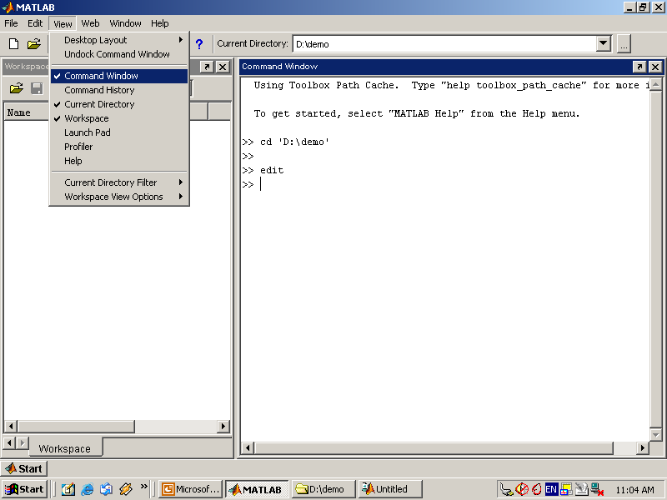

Use the Command Window to enter variables and run functions and M-files.

* **Command History**

Lines you enter in the Command Window are logged in the Command History window. In the Command History, you can view previously used functions, and copy and execute selected lines. To save the input and output from a MATLAB session to a file, use the diary function.

* **Running External Programs**

You can run external programs from the MATLAB Command Window. The exclamation point character! is a shell escape and indicates that the rest of the input line is a command to the operating system. This is useful for invoking utilities or running other programs without quitting MATLAB. On Linux, for example,!emacs magik.m invokes an editor called emacs for a file named magik.m. When you quit the external program, the operating system returns control to MATLAB.

* **Launch Pad**

MATLAB's Launch Pad provides easy access to tools, demos, and documentation.

* **Help Browser**

Use the Help browser to search and view documentation for all your Math Works products. The Help browser is a Web browser integrated into the MATLAB desktop that displays HTML documents.

To open the Help browser, click the help button in the toolbar, or type helpbrowser in the Command Window. The Help browser consists of two panes, the Help Navigator, which you use to find information, and the display pane, where you view the information.

* **Help Navigator**

Use to Help Navigator to find information. It includes:

* **Product filter**

Set the filter to show documentation only for the products you specify.

* **Contents tab**

View the titles and tables of contents of documentation for your products.

* **Index tab**

Find specific index entries (selected keywords) in the MathWorks documentation for your products.

* **Search tab**

Look for a specific phrase in the documentation. To get help for a specific function, set the Search type to Function Name.

* **Favorites tab**

View a list of documents you previously designated as favorites.

* **Display Pane**

After finding documentation using the Help Navigator, view it in the display pane. While viewing the documentation, you can:

* **Browse to other pages**

Use the arrows at the tops and bottoms of the pages, or use the back and forward buttons in the toolbar.

* **Bookmark pages**

Click the Add to Favorites button in the toolbar.

* **Print pages**

Click the print button in the toolbar.

* **Find a term in the page**

Type a term in the Find in page field in the toolbar and click Go.

Other features available in the display pane are: copying information, evaluating a selection, and viewing Web pages.

**Current Directory Browser**

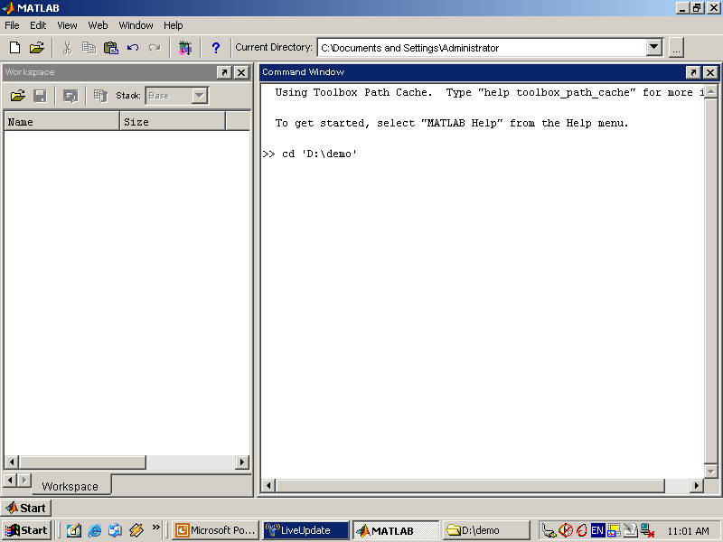

MATLAB file operations use the current directory and the search path as reference points. Any file you want to run must either be in the current directory or on the search path.

**Search Path**

To determine how to execute functions you call, MATLAB uses a search path to find M-files and other MATLAB-related files, which are organized in directories on your file system. Any file you want to run in MATLAB must reside in the current directory or in a directory that is on the search path. By default, the files supplied with MATLAB and MathWorks toolboxes are included in the search path.

* **Workspace Browser**

The MATLAB workspace consists of the set of variables (named arrays) built up during a MATLAB session and stored in memory. You add variables to the workspace by using functions, running M-files, and loading saved workspaces.

To view the workspace and information about each variable, use the Workspace browser, or use the functions who and whos.

To delete variables from the workspace, select the variable and select Delete from the Edit menu. Alternatively, use the clear function.

The workspace is not maintained after you end the MATLAB session. To save the workspace to a file that can be read during a later MATLAB session, select Save Workspace As from the File menu, or use the save function. This saves the workspace to a binary file called a MAT-file, which has a .mat extension. There are options for saving to different formats. To read in a MAT-file, select Import Data from the File menu, or use the load function.

* **Array Editor**

Double-click on a variable in the Workspace browser to see it in the Array Editor. Use the Array Editor to view and edit a visual representation of one- or two-dimensional numeric arrays, strings, and cell arrays of strings that are in the workspace.

* **Editor/Debugger**

Use the Editor/Debugger to create and debug M-files, which are programs you write to run MATLAB functions. The Editor/Debugger provides a graphical user interface for basic textediting, as well as for M-file debugging.

You can use any text editor to create M-files, such as Emacs, and can use preferences (accessible from the desktop File menu) to specify that editor as the default. If you use another editor, you can still use the MATLAB Editor/Debugger for debugging, or you can use debugging functions, such as dbstop, which sets a breakpoint.

If you just need to view the contents of an M-file, you can display it in the Command Window by using the type function.

**6.5.2 ANALYZING AND ACCESSING DATA**

MATLAB supports the entire data analysis process, from acquiring data from external devices and databases, through preprocessing, visualization, and numerical analysis, to producing presentation-quality output.

* **Data Analysis**

MATLAB provides interactive tools and command-line functions for data analysis operations, including:

* Interpolating and decimating
* Extracting sections of data, scaling, and averaging
* Thresholding and smoothing
* Correlation, Fourier analysis, and filtering
* 1-D peak, valley, and zero finding
* Basic statistics and curve fitting
* Matrix analysis

**Data Access**

MATLAB is an efficient platform for accessing data from files, other applications, databases, and external devices. You can read data from popular file formats, such as Microsoft Excel; ASCII text or binary files; image, sound, and video files; and scientific files, such as HDF and HDF5. Low-level binary file I/O functions let you work with data files in any format. Additional functions let you read data from Web pages and XML.

**Visualizing Data**

All the graphics features that are required to visualize engineering and scientific data are available in MATLAB. These include 2-D and 3-D plotting functions, 3-D volume visualization functions, tools for interactively creating plots, and the ability to export results to all popular graphics formats. You can customize plots by adding multiple axes; changing line colors and markers; adding annotation, Latex equations, and legends; and drawing shapes.

**2-D Plotting**

Visualizing vectors of data with 2-D plotting functions that create:

* Line, area, bar, and pie charts.
* Direction and velocity plots.
* Histograms.
* Polygons and surfaces.
* Scatter/bubble plots.
* Animations.

**6.5.3 PERFORMING NUMERIC COMPUTATION**

MATLAB contains mathematical, statistical, and engineering functions to support all common engineering and science operations. These functions, developed by experts in mathematics, are the foundation of the MATLAB language. The core math functions use the LAPACK and BLAS linear algebra subroutine libraries and the FFTW Discrete Fourier Transform library. Because these processor-dependent libraries are optimized to the different platforms that MATLAB supports, they execute faster than the equivalent C or C++ code.

MATLAB provides the following types of functions for performing mathematical operations and analyzing data:

* Matrix manipulation and linear algebra.
* Polynomials and interpolation.
* Fourier analysis and filtering.
* Data analysis and statistics.
* Optimization and numerical integration.
* Ordinary differential equations (ODEs).
* Partial differential equations (PDEs).
* Sparse matrix operations.

MATLAB can perform arithmetic on a wide range of data types, including doubles, singles, and integers.

**CHAPTER 7**

**ALGORITHM**

**Contrast Limited Adaptive Histogram Equalization**

Contrast limited adaptive histogram equalization (CLAHE) is a popular technique in biomedical image processing, since it is very effective in making the usually interesting salient parts more visible. The image is split into disjoint regions, and in each region local histogram equalization is applied. Then, the boundaries between the regions are eliminated with a bilinear interpolation.

The main objective of this method is to define a point transformation within a local fairly large window with the assumption that the intensity value within it is a stoical representation of local distribution of intensity value of the whole image. The local window is assumed to be unaffected by the gradual variation of intensity between the image centres and edges. The point transformation distribution is localised around the mean intensity of the window and it covers the entire intensity range of the image.

Consider a running sub image W of N X N pixels centred on a pixel P (i,j) , the image is filtered to produced another sub image P of (N X N) pixels according to the equation below

Where

and *Max* and *Min* are the maximum and minimum intensity values in the whole image, while and indicate the local window mean and standard deviation which are defined as:

As a result of this adaptive histogram equalization, the dark area in the input image that was badly illuminated has become brighter in the output image while the side that was highly illuminated remains or reduces so that the whole illumination of the image is same.

**COLOR FEATURE**

The color feature is one of the most widely used visual features in image retrieval. The construction of the color histogram is a straightforward process, including scanning the image, assigning color values to the resolution of the histogram, and building the histogram using color components as indices. There exist various color model to describe color information.

A color model is specified in terms of 3-D coordinate system and a subspace within that system where each color is represented by a single point. The more commonly used color models are *RGB* (red, green, blue), *HSV* (hue, saturation, value) and YCbCr (luminance and chrominance). We extracted the mean, standard deviation values of the color channels.

**SHAPE FEATURE**

Shape is an important visual feature and it is one of the primitive features for image content description. Shape content description is difficult to define because measuring the similarity between shapes is difficult. Region-based methods use the whole area of an object for shape description. The Area, Major Axis length and Minor Axis length are the features measured for the given image.

**SVM CLASSIFICATION**

Finally, SVM classifier is made using the whole model of feature subset selection. The pattern classification is defined as the task to categorize any object within a given category called class. For this paper, the classification stage was made using a support vector machine (SVM).

**CHAPTER 8**

**IMPLEMENTATION RESULTS**

**7.1 SCREENSHOTS**

**1. INPUT IMAGE**

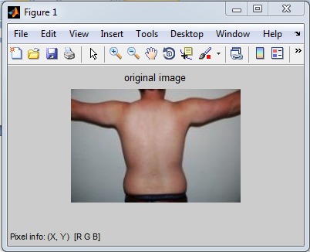

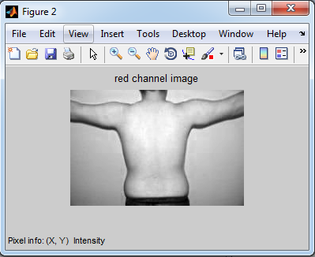

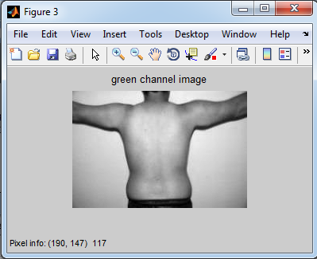

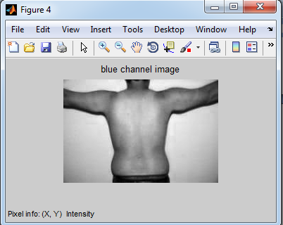

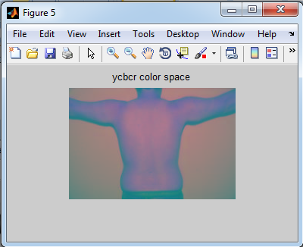

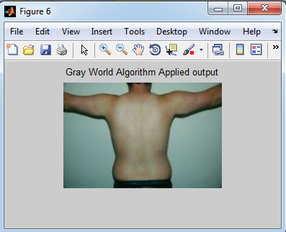

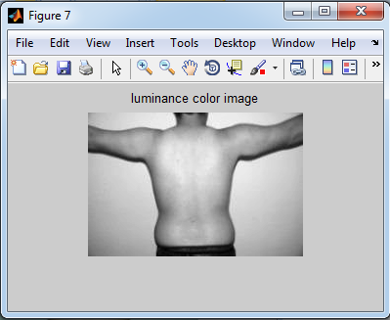

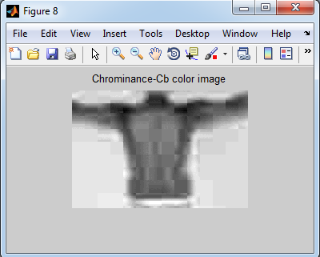

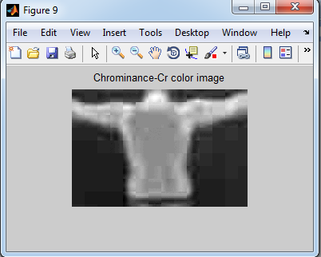

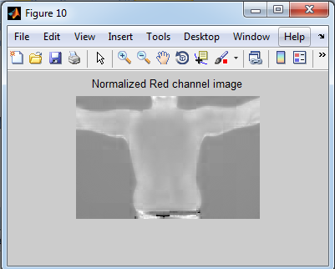

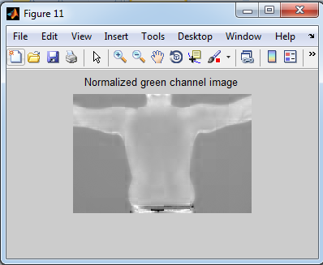

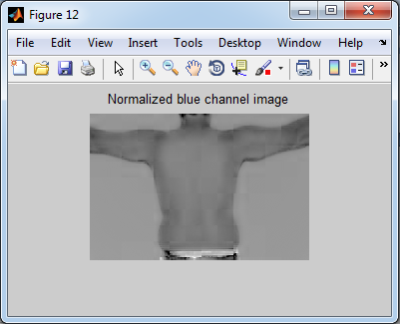

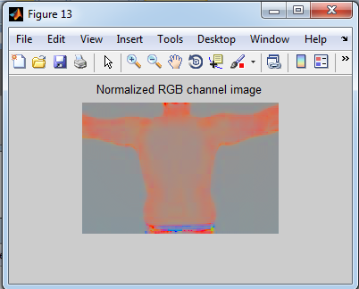

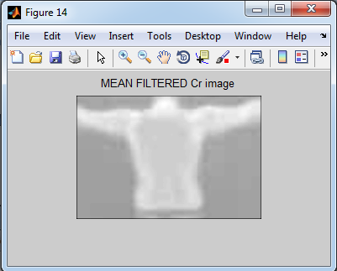

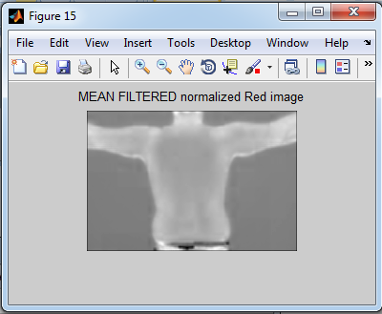

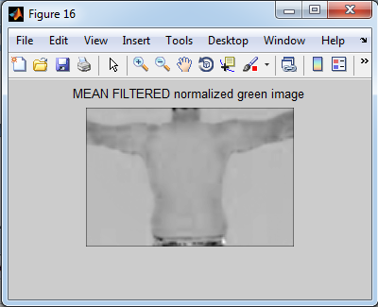

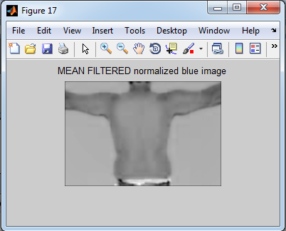

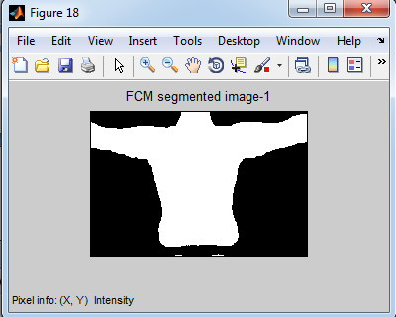

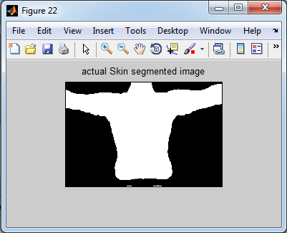

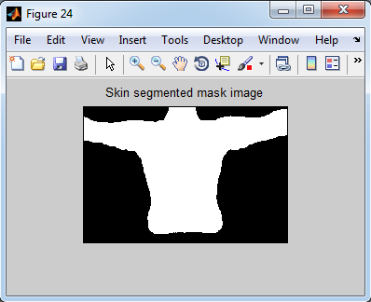

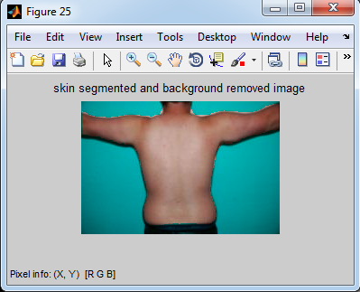

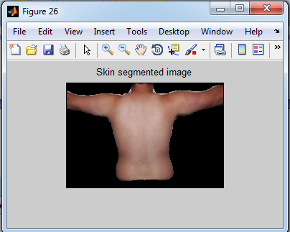

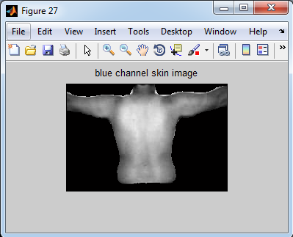

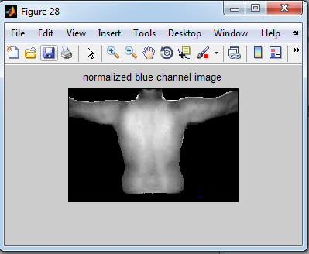

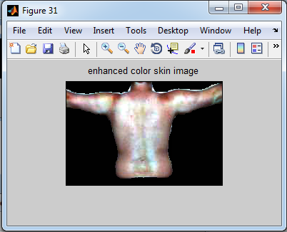

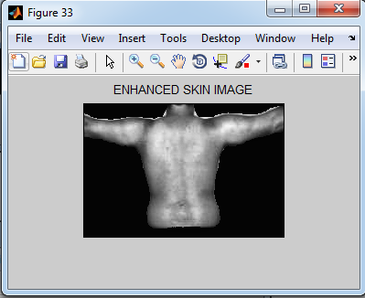

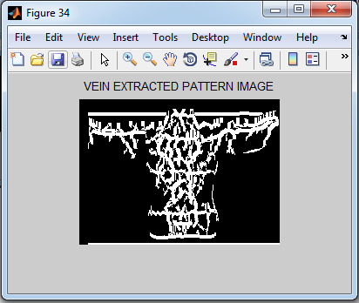

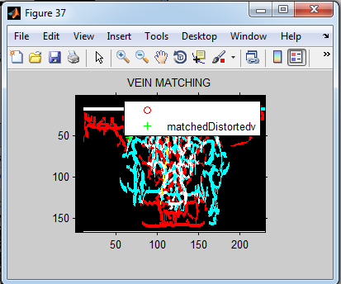

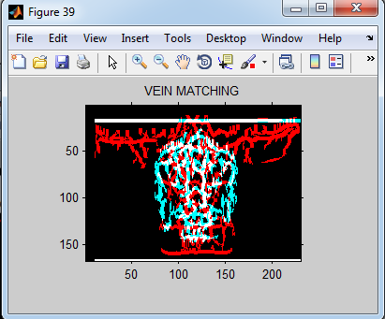

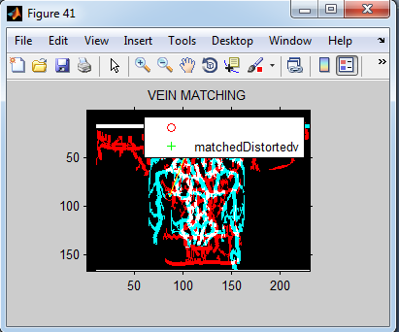

**FINAL OUTPUT**

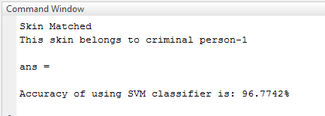

**CHAPTER 8**

**CONCLUSION AND REFERENCES**

**8.1 CONCLUSION**

In this paper, we have proposed we propose Contrast Limited Adaptive Histogram Equalization (CLAHE) based image enhancement method to improve the contrast of the skin image. The enhanced image is segmented and the vein pattern is extracted. While it is rare to observe the criminals’ faces in the evidence images of child sexual abuse, masked gunmen, and riots, their non-facial body parts are often visible. To identify the criminals in these skin images, an automated vein pattern identification system, this is comprised of skin segmentation, vein pattern extraction, and matching algorithms, is proposed in this work. We also extract the vein pattern of the criminals. Different images of same person were matched with each other and hence we achieved high recognition rate and accuracy.

**8.2 REFERENCES**

[1] A. Nurhudatiana, A.W.-K. Kong, K. Matinpour, D. Chon, L. Altieri, S.Y. Cho, and N. Craft, “The Individuality of Relatively Permanent Pigmented or Vascular Skin Marks (RPPVSM) in Independently and Uniformly Distributed Patterns,” *IEEE TIFS*, vol. 8, no. 6, pp. 998-1012, 2013.

[2] D. Lin and X. Tang, “Recognize High Resolution Faces: From Macrocosm to Microcosm,” in *Proc. IEEE CVPR*, pp. 1355-1362, 2006.

[3] J.S. Pierrard and T. Vetter, “Skin Detail Analysis for Face Recognition,” in *Proc. CVPR*, pp. 1-8, 2007.

[4] Z. Zhang, S. Tulyakov, and V. Govindaraju, “Combining Facial Skin Mark and Eigenfaces for Face Recognition,” in *Proc. ICB*, pp. 424-433, 2009.

[5] U. Park and A.K. Jain, “Face Matching and Retrieval Using Soft Biometrics,” *IEEE TIFS*, vol. 5, no. 3, pp. 406-415, 2010.

[6] N. Srinivas, G. Aggarwal, P.J. Flynn, and R.W.V. Bruegge, “Analysis of Facial Marks to Distinguish Between Identical Twins,” *IEEE TIFS*, vol. 7, no. 5, pp. 1536-1550, 2012.

[7] D.G. Lowe, “Distinctive Image Features from Scale Invariant Keypoints,” *IJCV*, vol. 60, no. 2, pp. 91-110, 2004.

[8] P.F. Felzenszwalb and D.P. Huttenlocher, “Pictorial Structures for Object Recognition,” *IJCV*, vol. 61, no. 1, pp. 55-79, 2005.

[9] V. Blanz and T. Vetter, “A Morphable Model for the Synthesis of 3D Faces,” in *SIGGRAPH ’99 Proc. 26th Annual Conf. Computer Graphics and Interactive Techniques*, pp. 187-194, Los Angeles, 1999.

[10] T.F. Cootes, G.J. Edwards, and C.J. Taylor, “Active Appearance Models,” in *Proc. ECCV*, vol. 2, pp. 484-498, 1998.

[11] D. Ziou and S. Tabbone, "Edge Detection Techniques: An Overview," *IJPRAI*, vol. 8, no. 4, pp. 537–559, 1998.

[12] A.K. Jain, K. Nandakumar, and A. Ross, “Score Normalization in Multimodal Biometric Systems,” *Pattern Recognition*, vol. 38, no. 12, pp. 2270-2285, 2005.

[13] T.F. Cootes, C.J. Taylor, D.H. Cooper, and J. Graham, “Active Shape Models-Their Training and Application,” *Computer Vision and Image Understanding*, vol. 61, no. 1, pp. 38-59, 1995.

[14] G. Loy and A. Zelinsky, “Fast Radial Symmetry for Detecting Points of Interest,” *IEEE TPAMI*, vol. 25, no. 8, pp. 959-973, 2003.

[15] P. Burt and E. Adelson, “The Laplacian Pyramid as a Compact Image Code,” *IEEE Trans. Communication*, vol. 31, no. 4, pp. 532-540, 1983.

[16] C. Bradley, *The Algebra of Geometry: Cartesian, Areal and Projective Co-Ordinates*, Bath: Highperception, 2007.

[17] S. Milborrow and F. Nicolls, “Locating Facial Features with an Extended Active Shape Model,” in *Proc. ECCV*, pp. 504-513, 2008.

[18] R. Friedman, D. Rigel, and A. Kopf, “Early Detection of Malignant Melanoma: The Role of Physician Examination and Self-Examination of the Skin,” *CA: A Cancer Journal for Clinicians*, vol. 35, no. 3, pp. 130-151, 1985.

[19] T.S. Cho, W.T. Freeman, and H. Tsao, “A Reliable Skin Mole Localization Scheme,” in *Proc. ICCV*, pp. 1-8, 2007.

[20] T.K. Lee, M.S. Atkins, M.A. King, S. Lau, and D.I. McLean, “Counting Moles Automatically From Back Images,” *IEEE Trans. Biomedical Engineering*, vol. 52, no. 11, pp. 1966-1969, 2005.